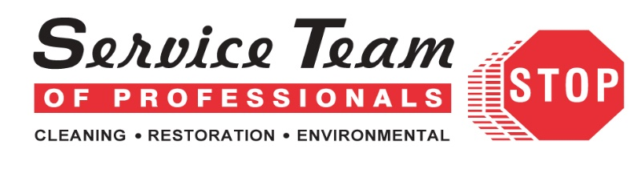
Do you suffer from allergies during the spring? It may be worsened by mold.
As temperatures start to warm and spring showers begin to fall, grass, trees and flowers begin to sprout back to life. With this comes pollen. As spring showers provide water to help vegetation grow, it also helps mold grow. With the combination of warmer weather and additional moisture from the rains, this provides the perfect opportunity for mold to distribute its spores and grow. For those that suffer from seasonal allergies, the addition of mold may worsen hay fever symptoms and make relief difficult to find.
Is it pollen or mold causing your hay fever?
Whether you’re suffering from pollen allergies or mold allergies, it’s hard to tell the difference. Sneezing, itchy eyes, and congestion are common signs of seasonal allergies. Mold allergies may cause the same symptoms. Additionally, mold allergy sufferers may also experience postnasal drip, nasal congestion, and coughing. If your allergies worsen in the evening or after a period of rain, it may be an indicator of a mold allergy, as mold becomes airborne from the impact of the showers and moisture in the air.
Prevention
While it may be difficult to help reduce your allergies while you’re outside in the lovely weather of the spring, it may be possible to reduce said allergies while indoors, especially if they’re caused by mold. Areas within a home that have the highest likelihood of microbial growth are as follows:
- Bathrooms
- Crawl spaces
- Attics
- Kitchens
The best way to prevent mold from growing in your home is to reduce the amount of moisture within and keeping the temperature on the warmer side. Avoid using humidifiers regularly and ensure air filtration devices are changed regularly.
Homes with crawl spaces should have them checked seasonally to ensure there is no standing water, moisture barriers are intact, and insulation is dry and properly installed. While mold is a common occurrence within crawl spaces, it’s important to have them inspected by professionals to prevent mold from taking over, potentially causing health concerns for the occupants.
Removal
There are some instances where you can clean up surface mold easily. On nonporous surfaces, using a spray bottle, an acceptable mixture of bleach and vinegar based on the manufacturer's recommendation can be used to clean and remove mildew. Here are some examples of nonporous surfaces you may find in your home dependent upon their building material:
- Sinks
- Countertops
- Bathtubs
- Windows
Crawl spaces and attics provide different challenges and are more difficult to clean. Due to the materials found in such areas, mold has a tendency to grow deep into exposed wood, which requires a more thorough cleaning approach. Cleaning agents that can penetrate deep into the wood, bringing spores to the surface, are not typically found for at home use.
Mold removal seems easy, but it really isn’t a DIY job. Typically, it requires a full array of personal protective equipment, containment barriers, and negative air machines. For mold remediation, you should seek help from a professional mold remediation company in Charlotte, NC, like ours.
For a free inspection and to remove mold from within your home or crawlspace, contact STOP Restoration Charlotte North. 704-309-7258.
For the best mold remediation services in Charlotte, NC, visit our website today.

